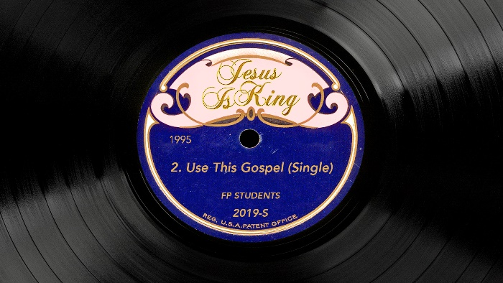

# *Jesus Is King* Week 2: Use This Gospel

## Life / Intro Questions

* What were your highs and lows of the last week?

## Connection Questions

* Have you ever felt like the world was trying to separate you from your faith? If so, how did you respond?
* Has there ever been a time in your life where you came up against something and you remembered a scripture that helped you through it?

## Sermon in a Sentence

* If you know your weapons, you’ll walk in victory.

## Scripture

**Matthew 4:1-11**: Then Jesus was led by the Spirit into the wilderness to be tempted by the devil. 2After fasting forty days and forty nights, he was hungry. 3The tempter came to him and said, “If you are the Son of God, tell these stones to become bread.” 4Jesus answered, “It is written: ‘Man shall not live on bread alone, but on every word that comes from the mouth of God.’” 5Then the devil took him to the holy city and had him stand on the highest point of the temple. 6“If you are the Son of God,” he said, “throw yourself down. For it is written: “‘He will command his angels concerning you, and they will lift you up in their hands, so that you will not strike your foot against a stone.’” 7Jesus answered him, “It is also written: ‘Do not put the Lord your God to the test.’” 8Again, the devil took him to a very high mountain and showed him all the kingdoms of the world and their splendor. 9“All this I will give you,” he said, “if you will bow down and worship me.” 10Jesus said to him, “Away from me, Satan! For it is written: ‘Worship the Lord your God, and serve him only.’” 11Then the devil left him, and angels came and attended him.

## Discussion Questions

* When you encounter hard times in life, how do you typically respond?
* What was Jesus’ response to the temptations of the enemy?
* How can we apply Jesus’ response to our life?

## Life Application

* What are some creative ways that you can memorize scripture to be prepared to call on them when tough times come your way?

## Take It Out

* Close your group time with prayer requests.
* Remind your students that RIGHT NOW is the best time to register for Fusion – they need to go to fusion.events tonight and lock in the super-low $49 price. The cost will increase in early December!
* Refuse to let money stand in the way – check FPSLeaders.com for a scholarship application if needed.